Harsh Chauhan
23321014
TEB – 103
ETE

Material | project Id | space group
NiO | mp-19009 | Fm3̅m
CoO | mp-22408 | F4̅3m
FeO | mp-1274279 | C2/m
TiO2 | mp-390 | I4₁/amd
RuO2 | mp-825 | P4₂/mnm
IrO2 | mp-2723 | P4₂/mnm
SrTiO3 | mp-5229 | Pm3̅m
LaMnO3 | mp-17554 | Pnma

b)
To quantitatively isolate and measure the D3-induced error, the following protocol was used:
Step 1: Selection of optimized structure
The optimized crystal structures of all eight transition metal oxides were obtained from the Materials Project database.
Step 2: Uniform lattice expansion
Each crystal structure was uniformly expanded by applying strain to the lattice parameter:
$$a_{i}=a_{0}(1+s_{i})$$
where:
- $a_{0}$= original lattice parameter
- $s_{i}$= applied strain
- $a_{i}$= strained lattice parameter
Step 3: D3 dispersion energy calculation
For every strained structure, the D3 dispersion energy $\left(E_{dis}\right)$was calculated and recorded.

Step 4: Plotting dispersion-energy curve
A graph of:
$$E_{dis} vs \text{Cell Length}$$
was plotted for each material.

Step 5: Identification of dip
The abnormal minimum point (dip) in the curve was identified:
$$E_{min}$$
This point corresponds to the strongest artificial lowering of D3 energy.

Step 6: Estimation of smooth baseline
A smooth baseline was constructed by connecting the pre-dip shoulder and post-dip recovered region:
$$E_{expected}(x)=mx+b$$
where:
$$m=\frac{E_{R}-E_{L}}{x_{R}-x_{L}} \\ b=E_{L}-mx_{L}$$

Step 7: Calculation of D3-induced error
The D3-induced error was calculated as:
$$ΔE=E_{min}-E_{expected,dip}$$
where:
- $E_{min}$= observed minimum dispersion energy
- $E_{expected,dip}$= expected smooth energy at dip position
Magnitude:
$$∣ΔE∣$$
represents the strength of D3-induced error.
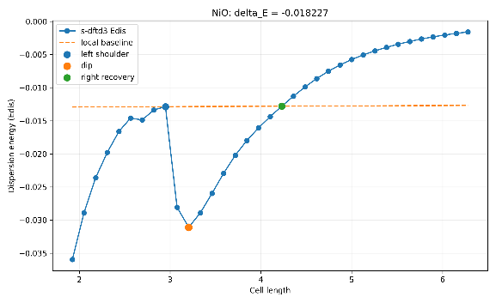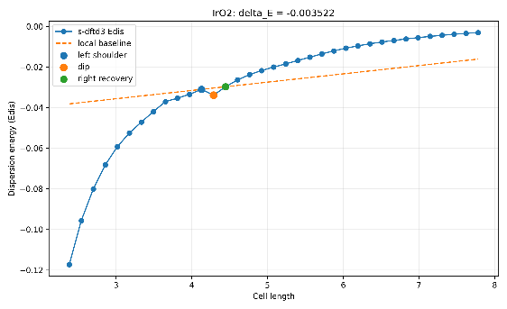

Figure: Representative dispersion-energy vs cell length plot showing pre-dip shoulder, artificial D3 dip $\left(E_{min}\right)$, and recovered post-dip region used for baseline fitting.

c)
The D3-induced error contribution was extracted for all eight transition metal oxides using the local peak-dip-recovery baseline method. The error was calculated using:
$$ΔE=E_{\text{min}}-E_{\text{expected,dip}}$$
where $E_{\text{min}}$is the observed minimum dispersion energy at the dip point, and $E_{\text{expected dip}}$is the expected smooth baseline energy at the same position. The magnitude $∣ΔE∣$represents the D3-induced error contribution.

Material | Material  Project ID | Space Group | Dip Cell Length | $$E_{min}$$ | $$E_{expected,dip}$$ | ΔE | $$∣ΔE∣$$
NiO | mp-19009 | Fm3̅m | 3.204498 | -0.031086 | -0.012859 | -0.018227 | 0.018227
CoO | mp-22408 | F4̅3m | 3.468908 | -0.042808 | -0.019069 | -0.023739 | 0.023739
FeO | mp-1274279 | C2/m | 2.720810 | -0.091038 | -0.046713 | -0.044324 | 0.044324
TiO2 | mp-390 | I4₁/amd | 5.144189 | -0.033192 | -0.013372 | -0.019820 | 0.019820
RuO2 | mp-825 | P4₂/mnm | 3.422476 | -0.047043 | -0.038392 | -0.008651 | 0.008651
IrO2 | mp-2723 | P4₂/mnm | 4.288553 | -0.033895 | -0.030374 | -0.003522 | 0.003522
SrTiO3 | mp-4651 | Pm3̅m | 7.174065 | -0.100512 | -0.038759 | -0.061753 | 0.061753
LaMnO3 | mp-17554 | Pnma | 8.513574 | -0.222176 | -0.089542 | -0.132634 | 0.132634

From the table, LaMnO₃ has the largest D3-induced error contribution, while IrO₂ has the smallest. The overall order of error magnitude is:
$$LaMnO_{3}>SrTiO_{3}>FeO>CoO>TiO_{2}>NiO>RuO_{2}>IrO_{2}$$

d)
The calculated D3-induced error magnitudes follow the order:
$$LaMnO_{3}>SrTiO_{3}>FeO>CoO>TiO_{2}>NiO>RuO_{2}>IrO_{2}$$
This trend indicates that D3-induced error depends strongly on structure type, ionic size, oxidation state, packing density, and electronic/geometric distortions.

Table 1: Summary of D3-induced error trend
Material | Structure Type | $$∣ΔE∣$$ | Key Reason for Trend
LaMnO₃ | Distorted Perovskite | 0.132634 | Large La ion + Jahn–Teller distortion + open structure
SrTiO₃ | Perovskite | 0.061753 | Large Sr ion + extended TiO₆ network
FeO | Distorted Rock Salt | 0.044324 | Lower symmetry + distorted Fe–O coordination
CoO | Rock Salt | 0.023739 | Moderate ionic packing
TiO₂ | Oxide Network | 0.019820 | Relatively regular TiO₆ arrangement
NiO | Rock Salt | 0.018227 | Compact symmetric ionic lattice
RuO₂ | Rutile | 0.008651 | Dense packing + smooth coordination change
IrO₂ | Rutile | 0.003522 | Most compact regular structure

Effect of structure type
Perovskite oxides show the highest D3-induced errors because they contain multiple coordination environments, large cation sites, and extended octahedral frameworks. During expansion, many weak long-range interactions change simultaneously, producing a stronger artificial dip.
Rock salt oxides show moderate error because their packing is compact and coordination is simpler.
Rutile oxides show the smallest error due to dense packing and regular octahedral arrangement, which keeps D3 variation smooth.
Table 2: Critical factors affecting D3-induced error
Factor | Effect on D3-induced Error | Example
Large ionic size | Increases polarizability → increases error | La³⁺, Sr²⁺
Open crystal packing | More weak long-range interactions | Perovskites
Structural distortion | Causes abrupt coordination change | LaMnO₃, FeO
High symmetry | Smooth D3 variation → smaller error | NiO, IrO₂
Dense packing | Reduces artificial dip | Rutile oxides

Effect of ionic size and oxidation state
Large ions such as La³⁺ and Sr²⁺ have high polarizability, increasing weak dispersion interactions and resulting in larger D3-induced errors.
Higher oxidation state ions such as Ti⁴⁺, Ru⁴⁺, and Ir⁴⁺ are smaller and more tightly bound, reducing dispersion-related artifacts.

Electronic and geometric effects
$LaMnO_{3}$contains Jahn–Teller active $Mn^{3+}$, producing unequal Mn–O bond lengths and strong structural distortion, which explains its highest D3-induced error.
$IrO_{2}$is an anomaly: despite heavy Ir atoms, it shows the lowest error because its compact rutile geometry dominates over atomic mass effects.

Conclusion
$$\text{Perovskite}>\text{Rock Salt}>\text{Rutile}$$
Thus, open, distorted, and highly polarizable structures show the largest D3-induced errors, whereas dense, symmetric, and compact structures show the smallest errors.

